ATM Maintenance System
POD 3
Riyaz Udeen S (915771)
Revanth Voleti (915770)
Sudharsan K (915829)
Naveen Kumar V (916025)
Mohammed Parvez A (916017)

Conceptual Model:
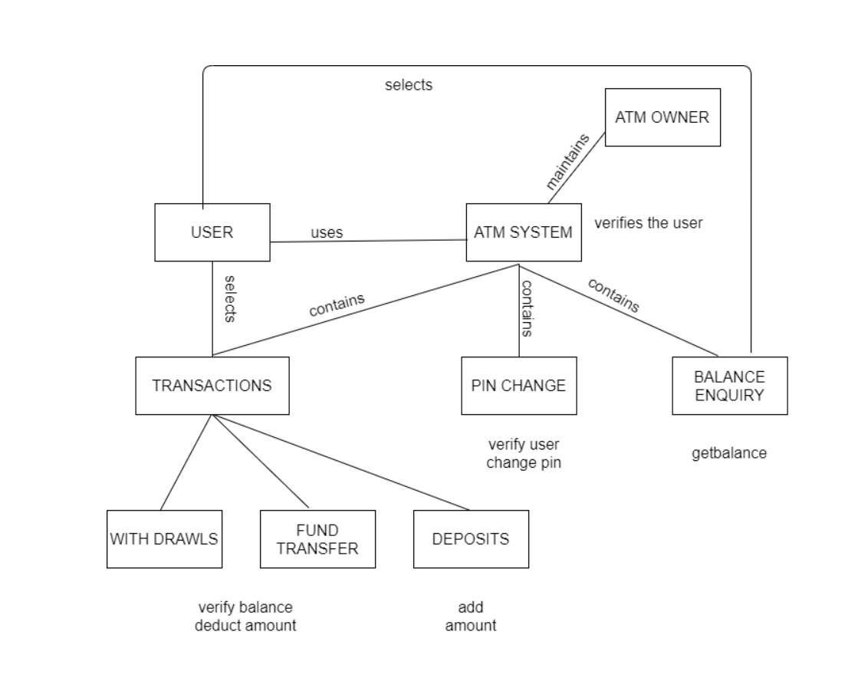

Class Diagram:
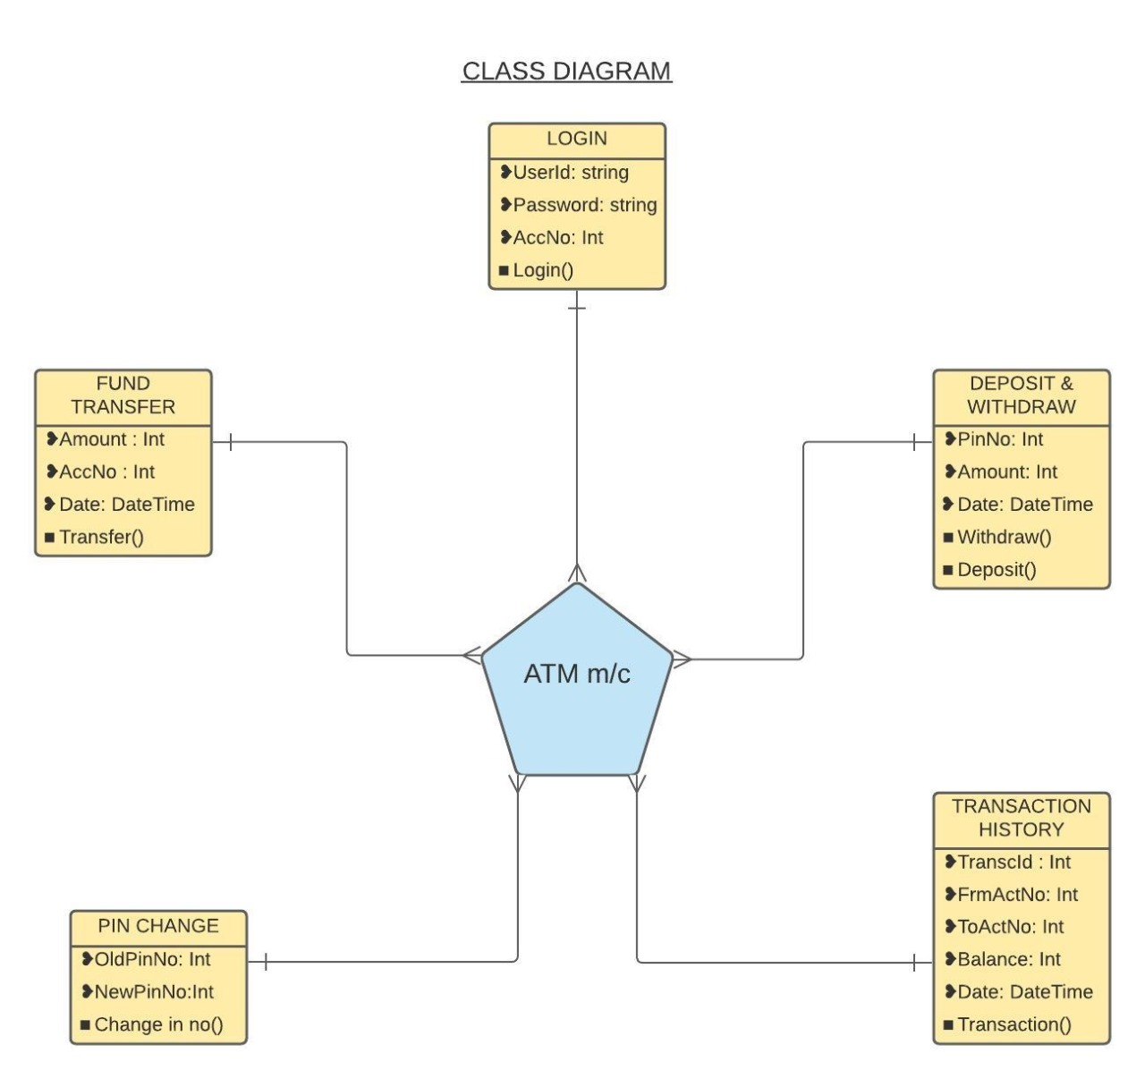

DB Design:

